

Final Project

INTRODUCTION TO DATABASE

Section: C

Topic name: Shop management system

**Supervised by**

MD.MASUM BILLAH

**Submitted By:-**

|  |  |
| --- | --- |
| SHIHAB UDDIN CHOWDHURY SHUVO | 22-49115-3 |
| SAMIUR RAHMAN | 22-49180-3 |
| TWASIN ABDULLAH MAHMOOD | 22-49097-3 |
| FAHMIDA YASMIN | 22-48119-2 |

Contents

1. Introduction 3
2. Topic Discussion 3-4
3. ER Diagram 4
4. Normalization 5-8
5. Table After Normalization 9
6. Finalization 9
7. Table Creation 10-20
8. Insertion 21-30
9. Query Test 31-39

10. Conclusion 40

Introduction:

This project is about a global bata footwear where managers lead various branches, employees connect with users, and suppliers ensure smooth product distribution. This project shows how these components work together, showcasing Bata’s prominent role in the industry.

Topic Discussion:

• The Bata footwear company has so many shop branches. Each shop branch has branch_name, unique branch_id,branch_country and a branch_location.

• Every branch has to be managed by one manager and one manager can only manage one branch. Manager has a name, a unique id, address, start_date(when he started working as a manager) and an email.

• In every branch has some employees without employees a branch can’t be created and an employee can only work for one branch at a time.

• Each employee has an employee_name, unique employee_id, employee_birth_date, employee_gender, employee_salary and employee_address.

• Employee works with users to sell product. Each user has a name and a unique id. Multiple employees can collaborates one user and one user can work with multiple employee.

• Some branches need supply of products. Each Product supplier can supply to multiple branches and each branches can buy products from multiple product supplier. Each product supplier has a name and an unique product id.

• The unique id is for uniquely identify

E-R Diagram:



Normalization

**Supplies:**

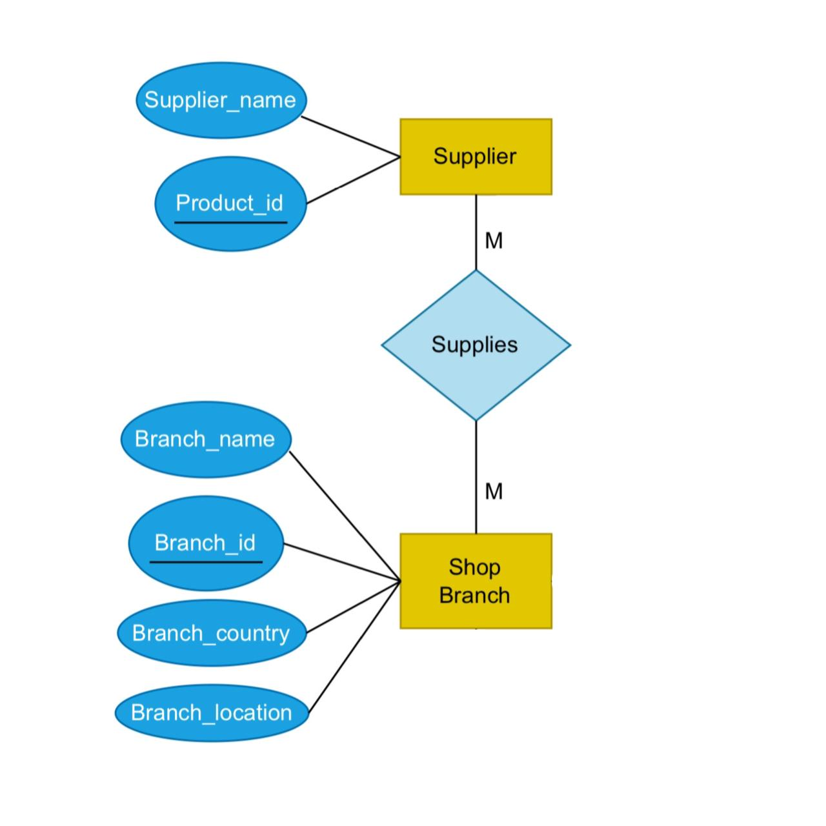

**UNF:** Product_id,Supplier_name,Branch_name,Branch_id,Branch_country,Branch_location

**1NF:** Product_id,Supplier_name,Branch_name,Branch_id,Branch_country,Branch_location

**2NF:**

1. Supplier_name,product_id
2. Branch_name,Branch_id, Branch_country,Branch_location
3. Branch_id , product_id

**3NF:**

1. Branch_location,Branch_id , Branch_name
2. Supplier_name , product_id Branch_location , Branch_country
3. Branch_id , product_id
4. Branch_location , Branch_country

**Manages:**

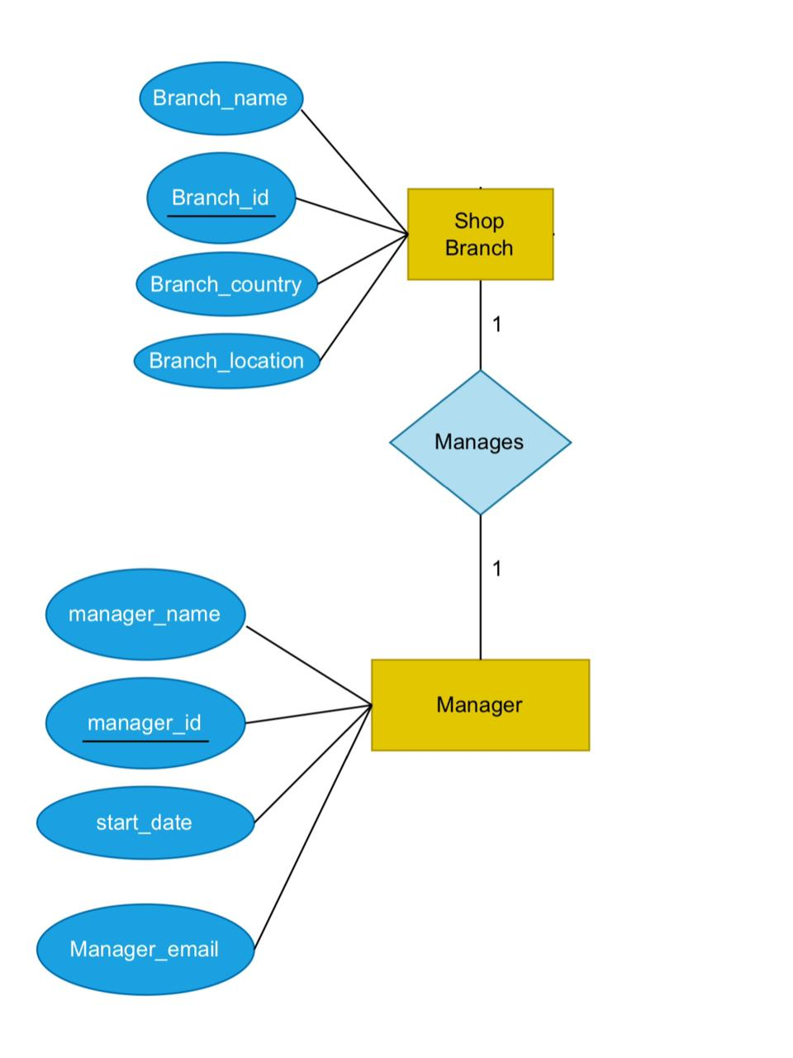

**UNF** : Branch_name,Branch_id,Branch_country,Branch_location, Manager_name, Manager_id, start_date, Manager_email

**1NF :** Branch_name,Branch_id ,Branch_country ,Branch_location , Manager_name , Manager_id, start_date , Manager_mail

**2NF :**

1. Branch_name, Branch_id, Branch_country,Branch_location
2. Manager_name , Manager_id , start_date , Manager_email
3. Branch_id (PK) , Manager_id (FK)

**3NF :**

1. Branch_location , Branch_id , Branch_name
2. Manager_name , Manager_id , start_date, Manager_email
3. Branch_id , Manager_id
4. Branch_location , Branch_country

**Works :**

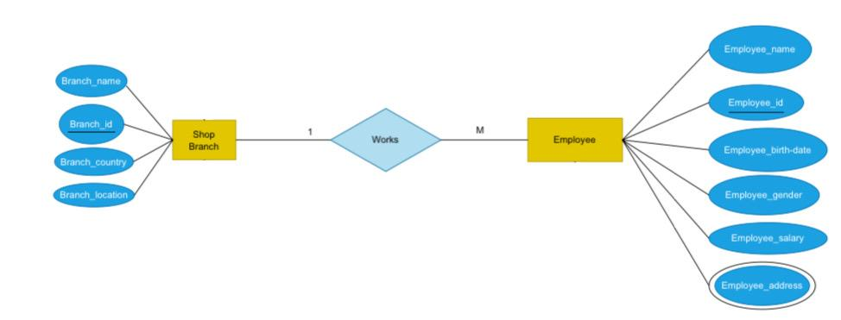

**UNF:** Branch_name,Branch_id,Branch_country,Branch_location , Employee_name, Employee_id , Employee_birth_date , Employee_gender , Employee_salary , Employee_address

**1NF:** Branch_name,Branch_id,Branch_country,Branch_location , Employee_name, Employee_id , Employee_birth_date , Employee_gender , Employee_salary , Employee_address

**2NF:**

1. Branch_name , Branch_id , Branch_country , Branch_location
2. Employee_name , Employee_id (PK) , Employee_birth_date , Employee_gender , Employee_salary , Employee_address , Branch_id (FK)

**3NF :**

1. Branch_name, Branch_id, Branch_locaton
2. Employee_name, Employee_id , Employee_birth_date, Employee_gender , Employee_salary,

Employee_address, Branch_id

1. Branch_location, Branch_country

**Collaborates :**

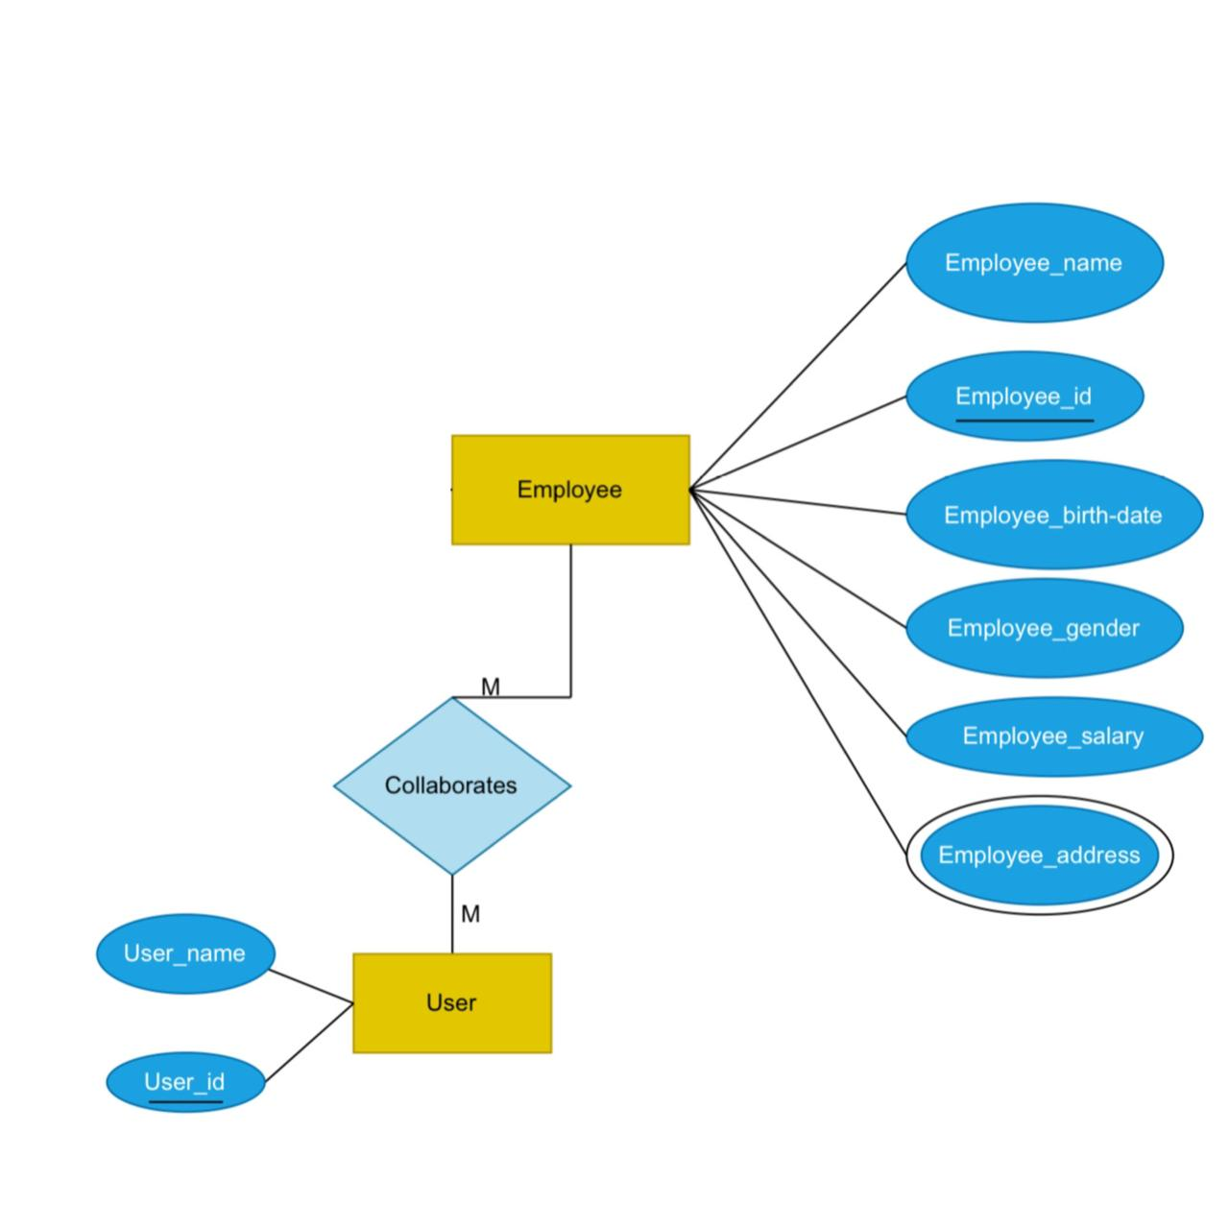

**UNF :** Employee_name , Employee_id , Employee_birth_date , Employee_gender , Employee_salary , Employee_address , User_name , User_id

**1NF :** Employee_name, Employee_id , Employee_birth_date , Employee_gender, Employee_salary, Employee_address, User_name, User_id

**2NF :**

1. Employee_name, Employee_id, Employee_birth_date, Employee_gender, Employee_salary,

Employee_address

1. User_name, User_id
2. Employee_id, User_id

**3NF:** Same as 2NF

**Table after normalization:**

1. S_name, P_id
2. Br_name, Br_id, Br_locaton
3. P_id, Br_id
4. Br_locaton, Br_country
5. Br_name, Br_id, Br_locaton
6. M_name, M_id, Start_date, M_email
7. Br_id, M_id
8. Br_locaton, Br_country
9. Br_name, Br_id, Br_locaton
10. E_name, E_id, E_birth_date, E_gender, E_salary,

E_address, Br_id

1. Br_location, Br_country
2. E_name, E_id, E_birth_date, E_gender, E_salary,

E_address

1. User_name, User_id
2. E_id, User_id

**Finalization-(Total 10 tables)**

1. Branch_name, Branch_id, Branch_locaton (shop branch)
2. Supplier_name, Product_id (supplier )
3. Product_id, Branch_id ( supply)
4. Branch_location, Branch_country(Location)
5. Manager_name, Manager_id, Start_date, Manager_email (manager)
6. Branch_id, Manager_id ( manage)
7. Employee_name, Employee_id, Employee_birth_date, Employee_gender, Employee_salary,

Employee_address, Branch_id (Work)

1. Employee_name, Employee_id, Employee_birth_date, Employee_gender, Employee_salary,

Employee_address (Employer)

1. User_name, User_id ( client)
2. Employee_id, User_id (collaborate)

Table creation :

Shop Branch:

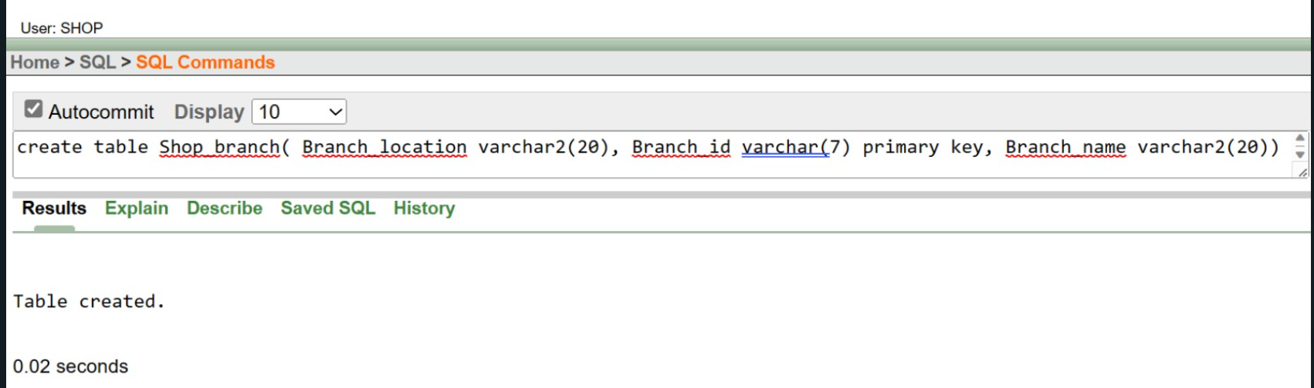

Figure-6.1

Creation command

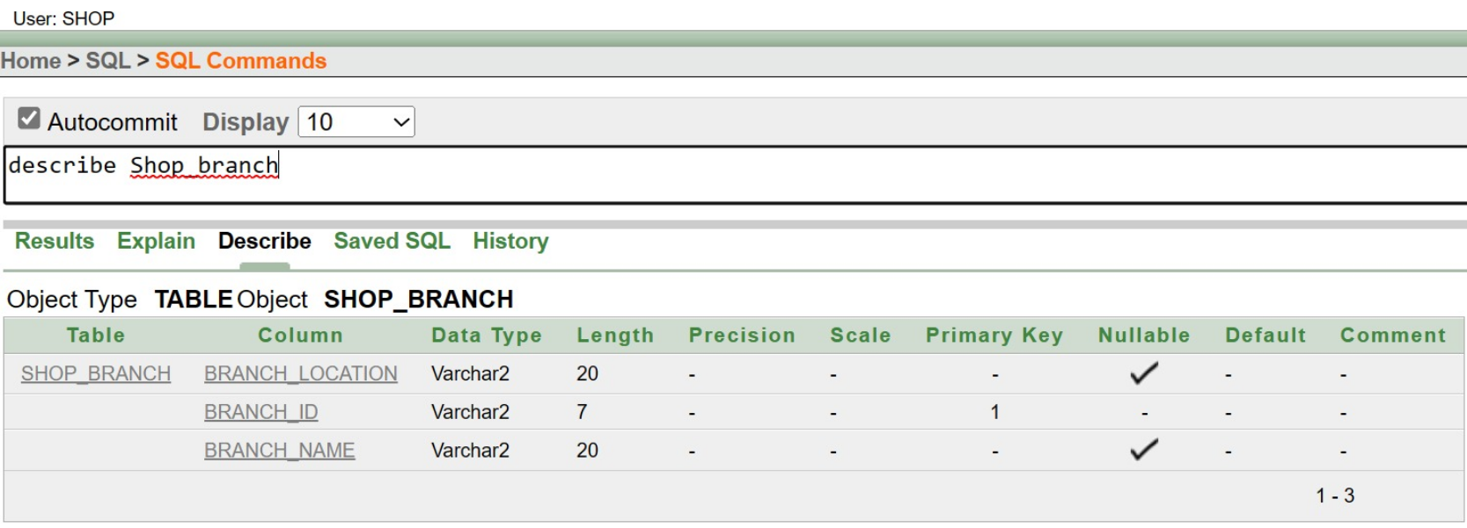

Figure-6.2: Describe command

Supplier:

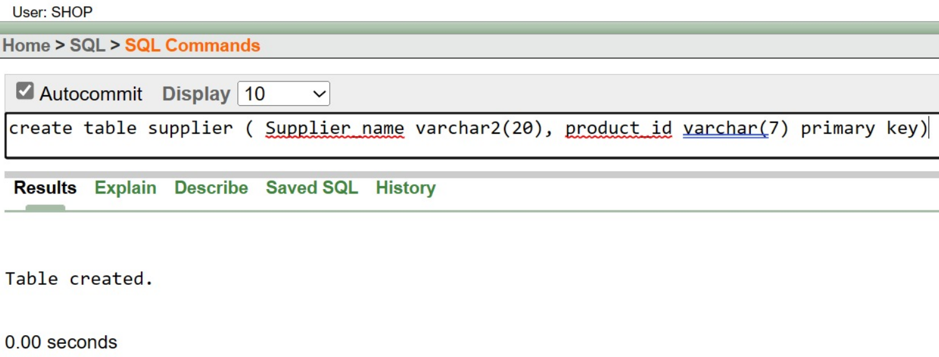

Figure-6.3: Creation Command

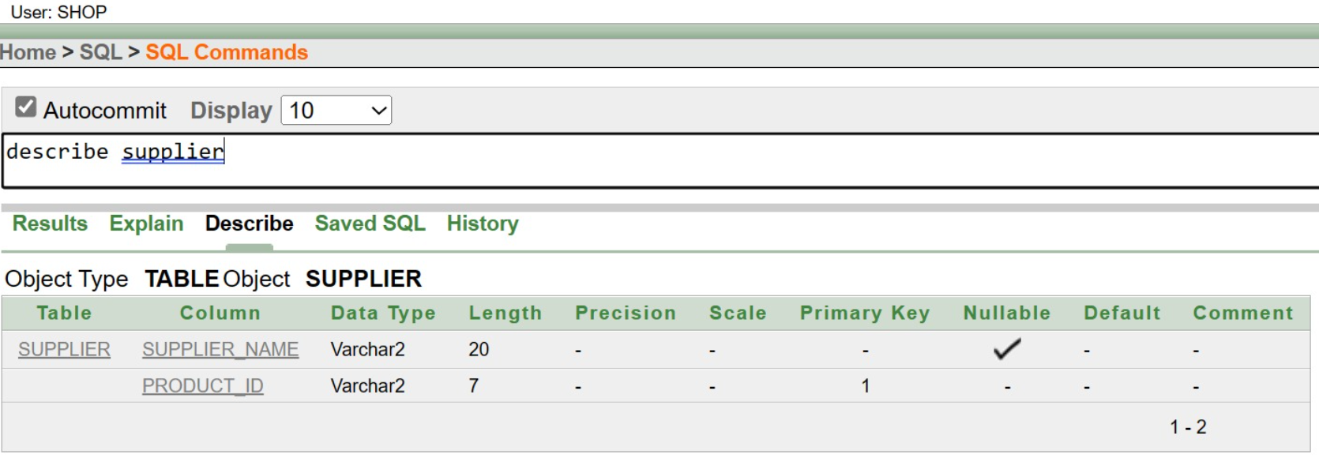

Figure-6.4: Describe Command

Supply:

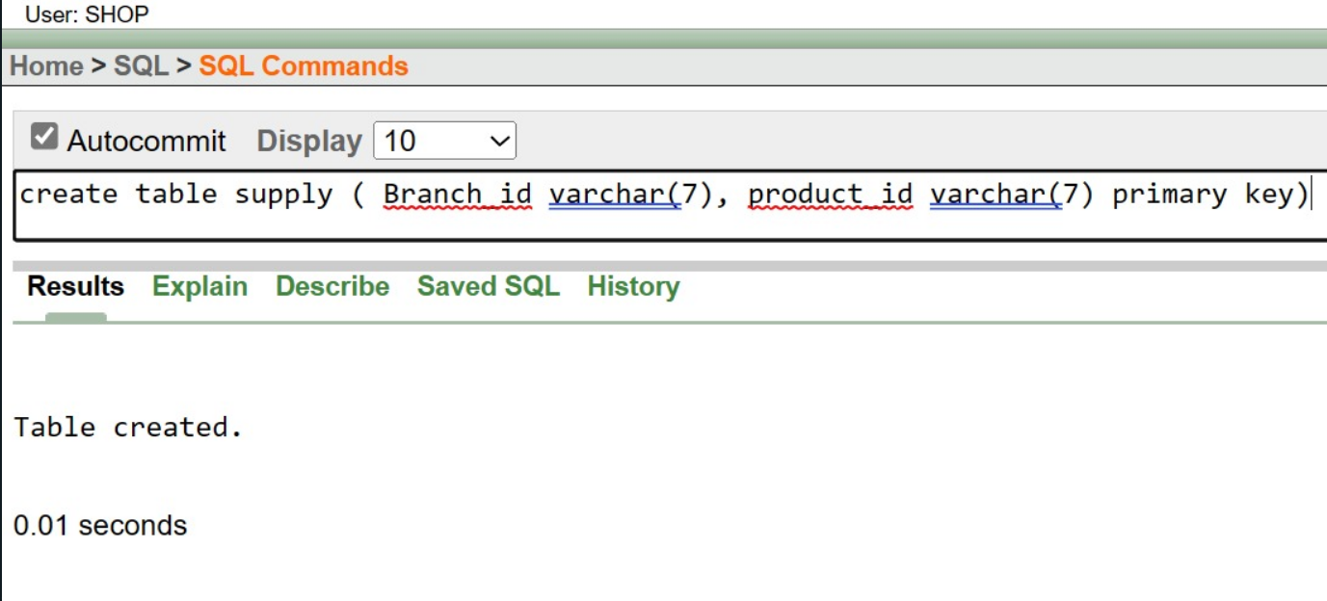

Figure-6.5: Creation Command

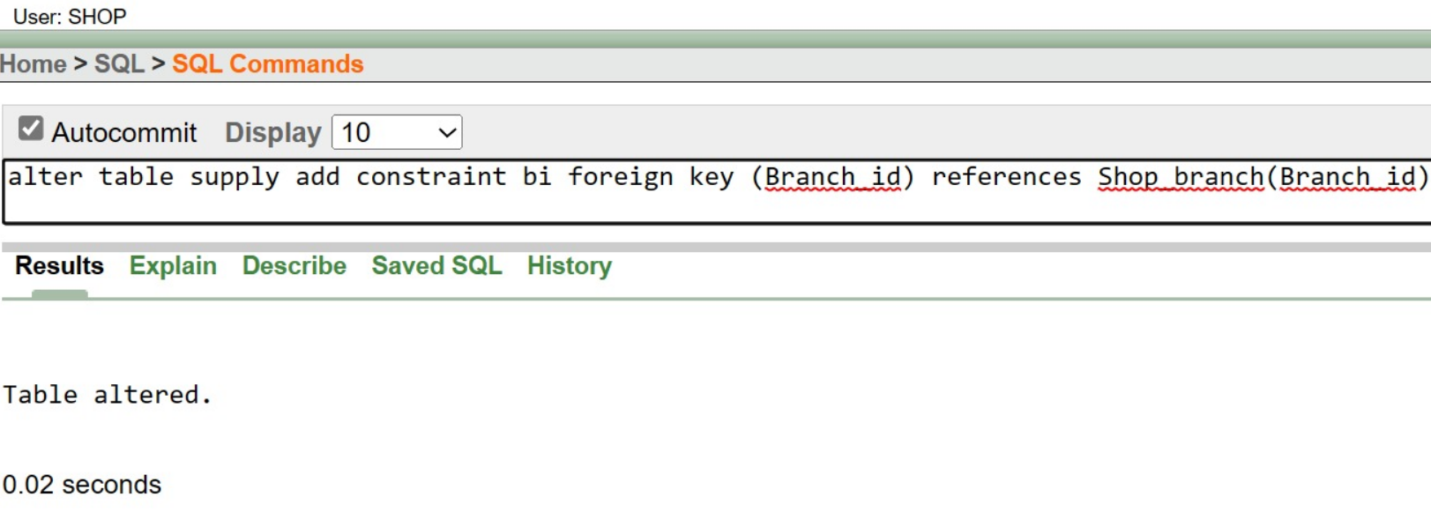

Figure-6.6: Altering Foreign key Command

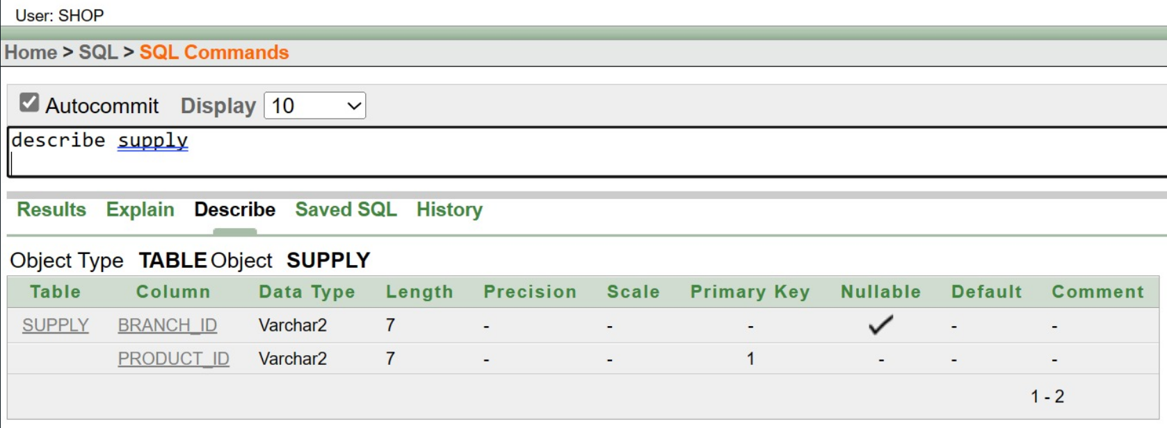

Figure-6.7: Describe Command

Location:

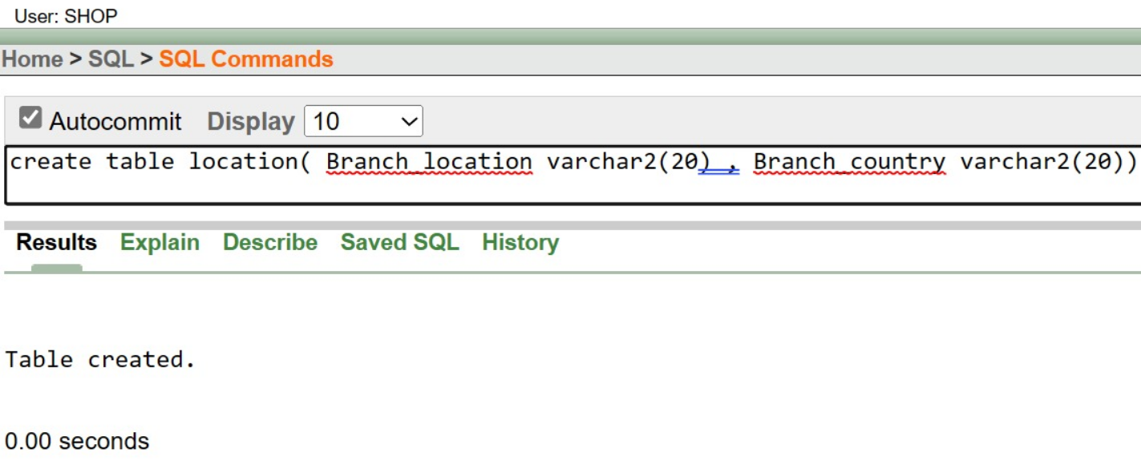

Figure-6.8: Creation Command

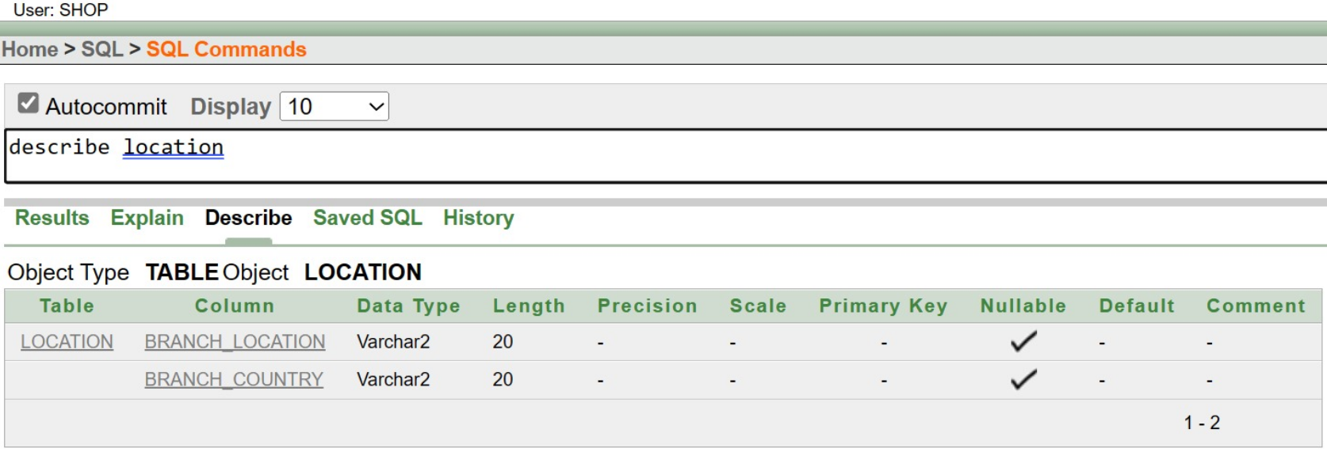

Figure-6.9: Describe Command

Manager:

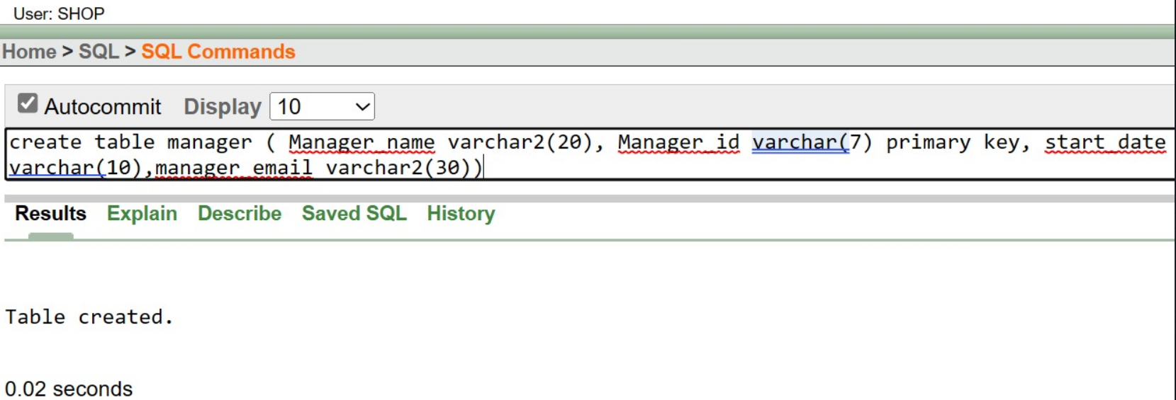

Figure-6.10: Creation Command

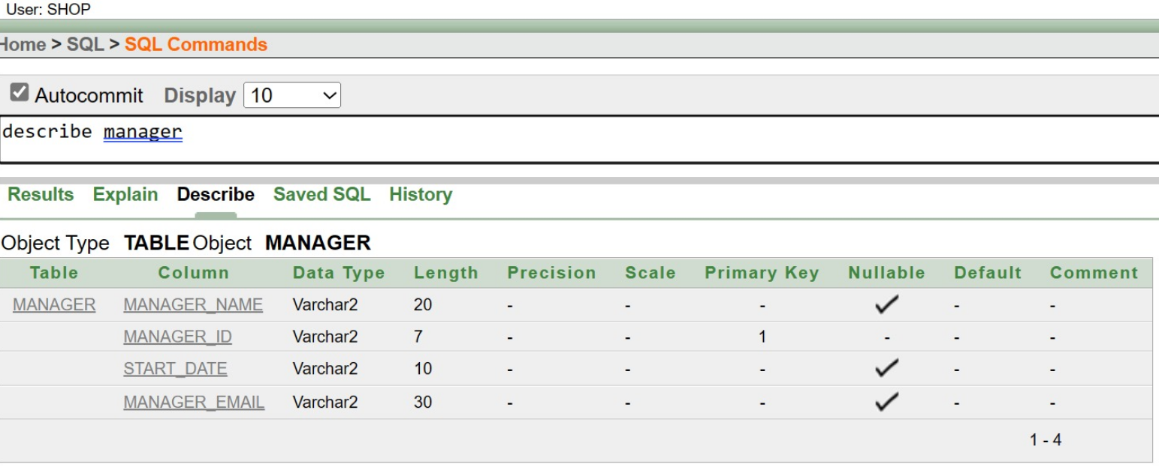

Figure-6.11: Describe Command

Manage:

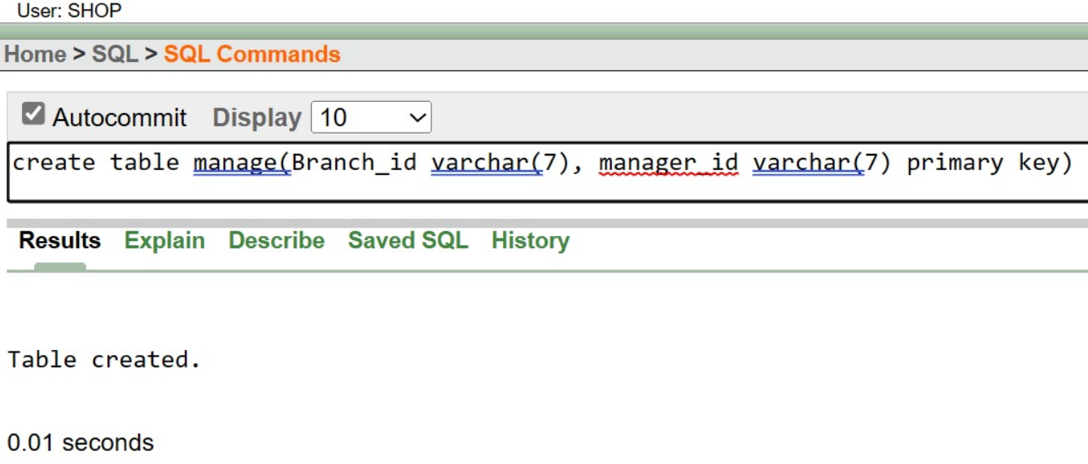

Figure-6.12: Creation Command

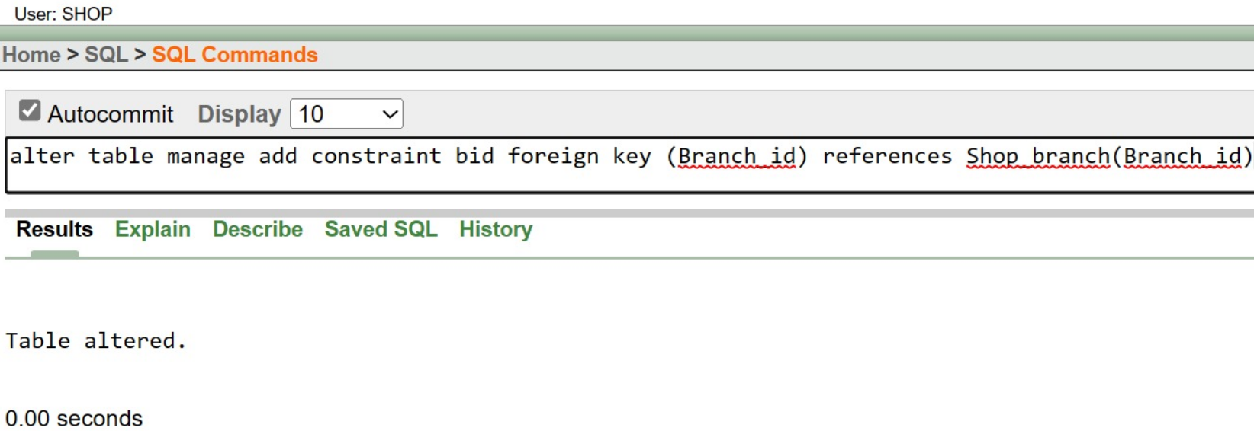

Figure-6.13: Alter foreign key Command

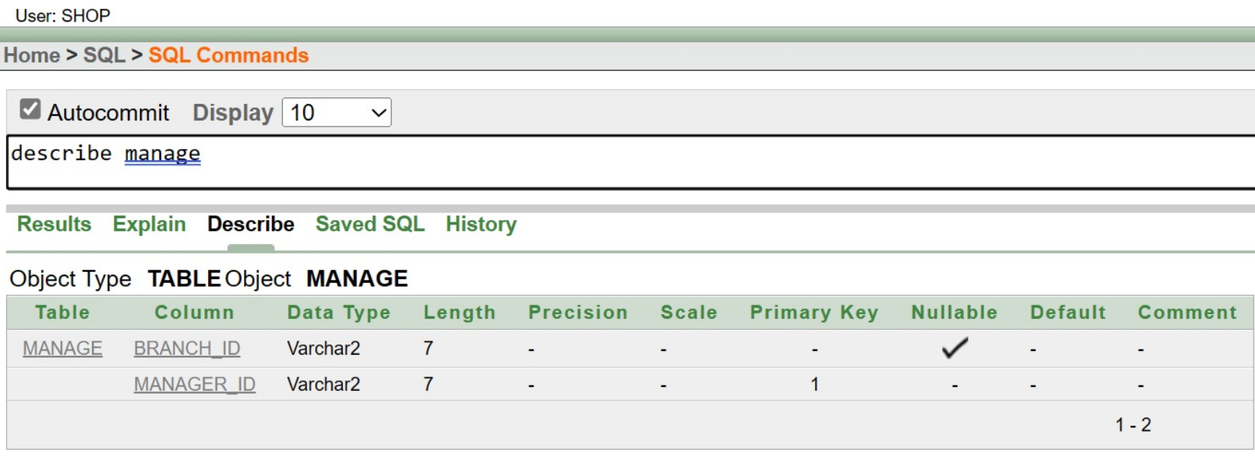

Figure-6.14: Describe command

Work:

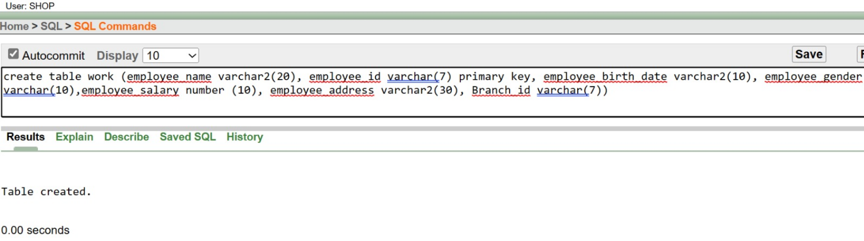

Figure-6.15: Creation Command

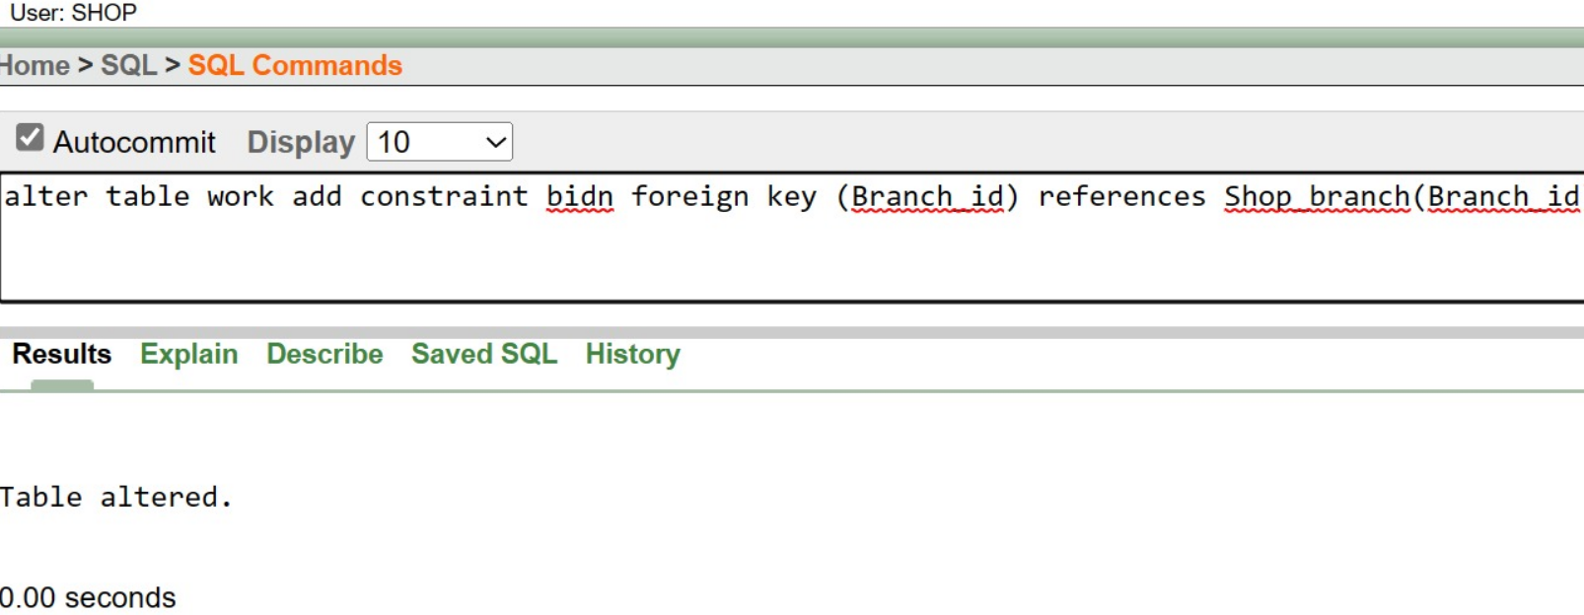

Figure-6.16: Altering Foreign key command

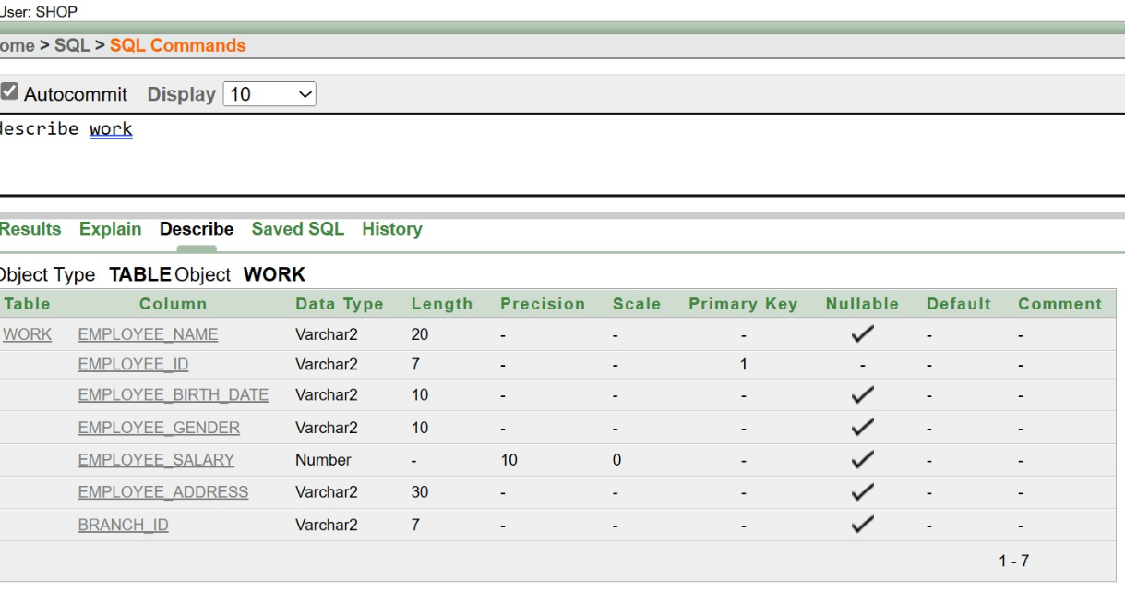

Figure-6.17: Describe Command

Employer:

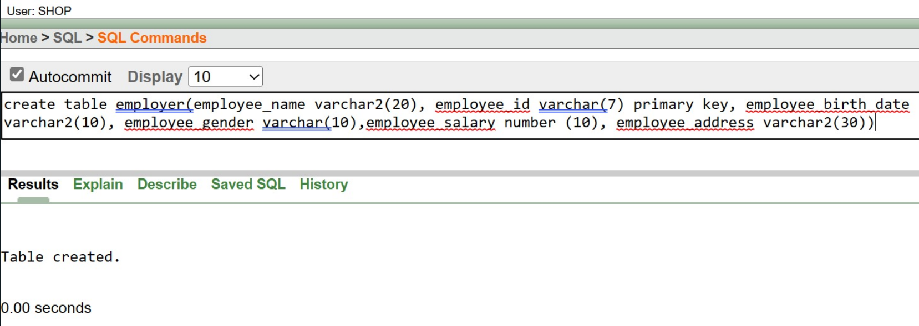

Figure-6.18: Creation Command

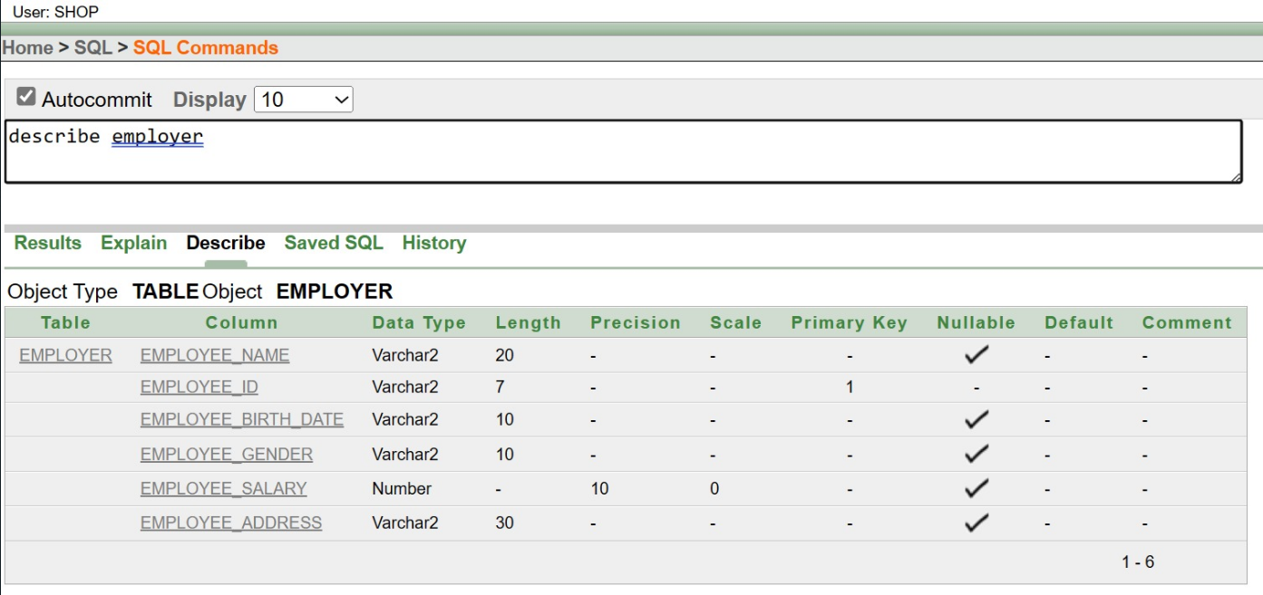

Figure-6.19: Describe Command

Client:

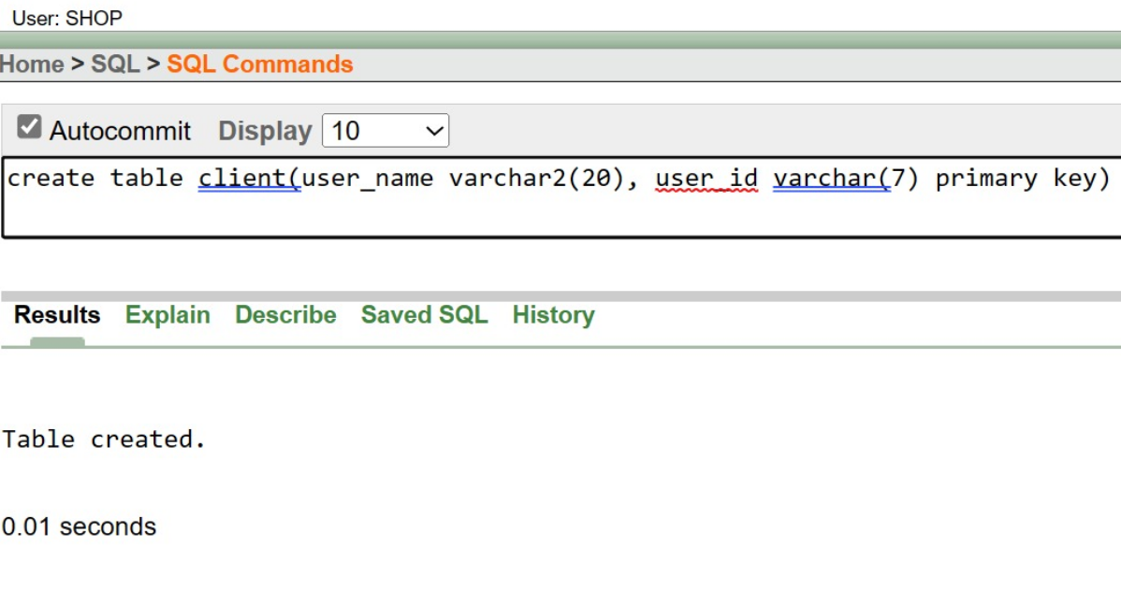

Figure-6.20: Creation Command

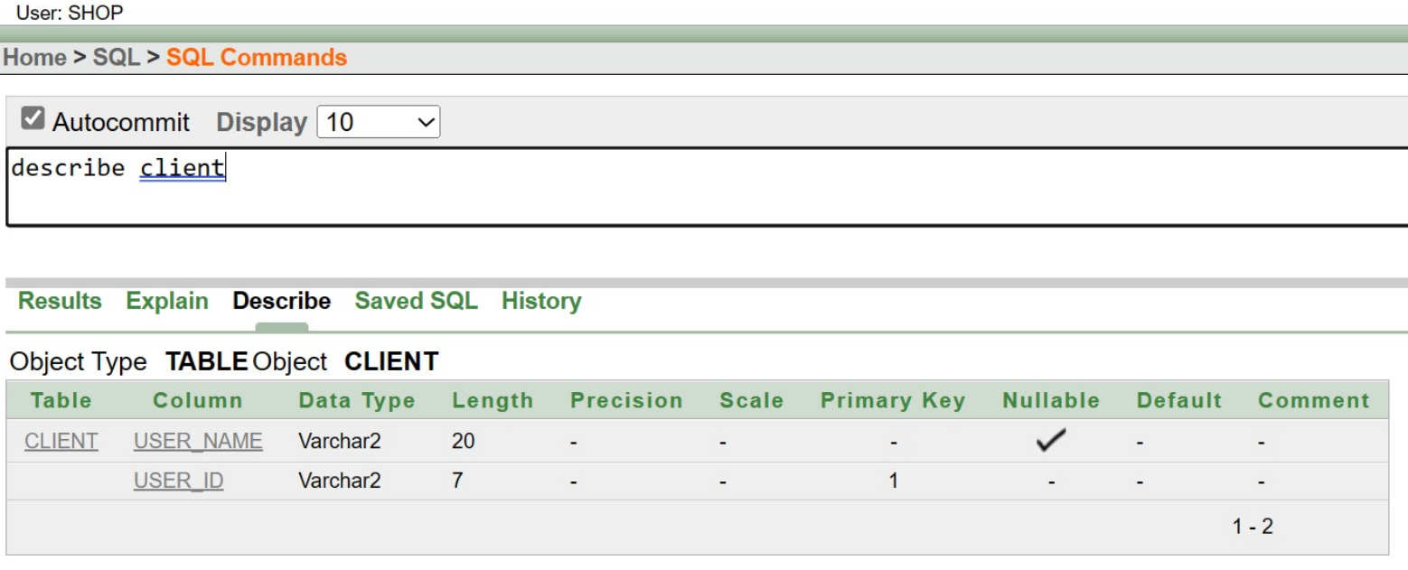

Figure-6.21: Describe Command

Collaborate:

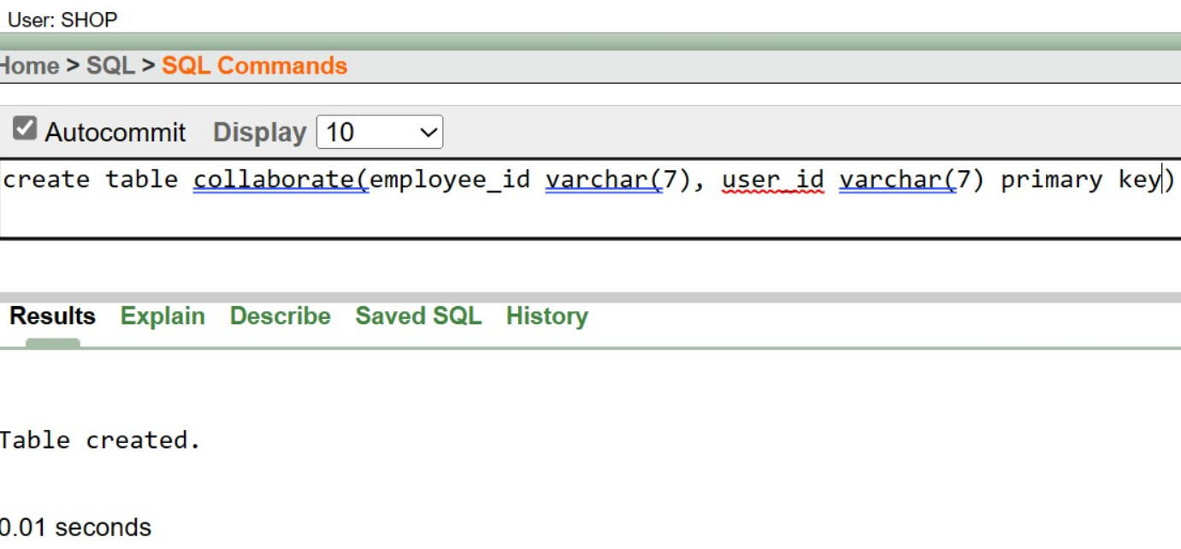

Figure-6.23: Creation Command

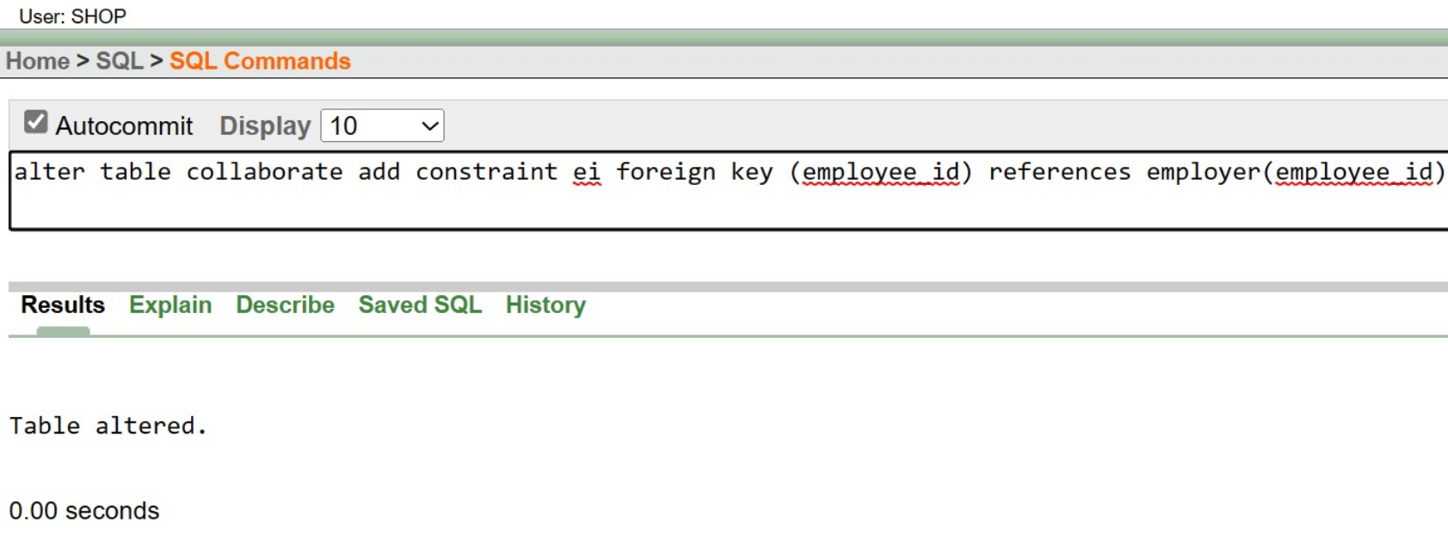

Figure-6.24: Altering Foreign key Command

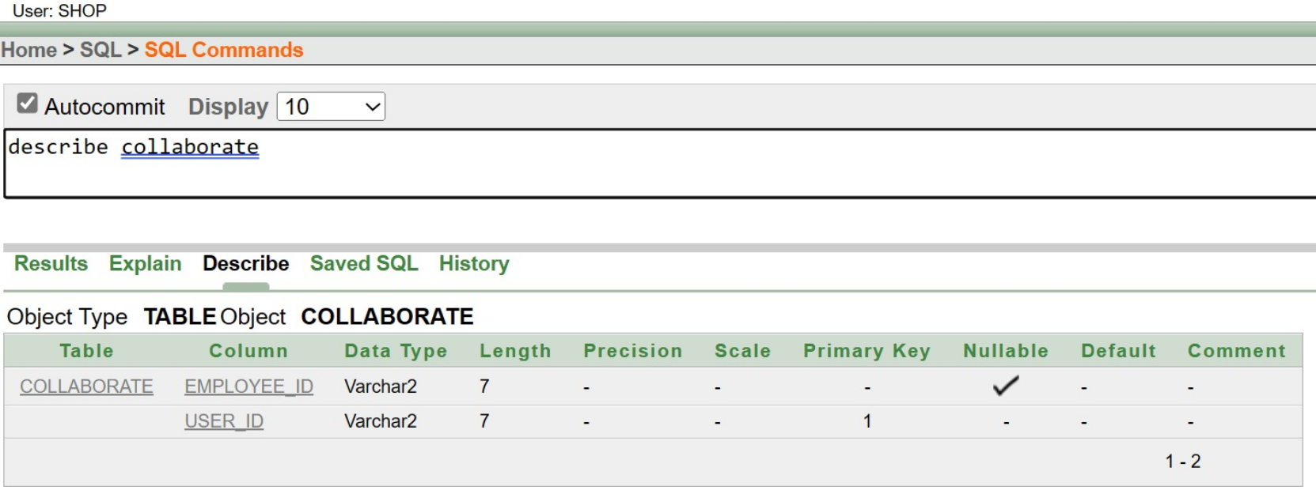

Figure-6.25: Describe Command

INSERTION:

Shop_branch:

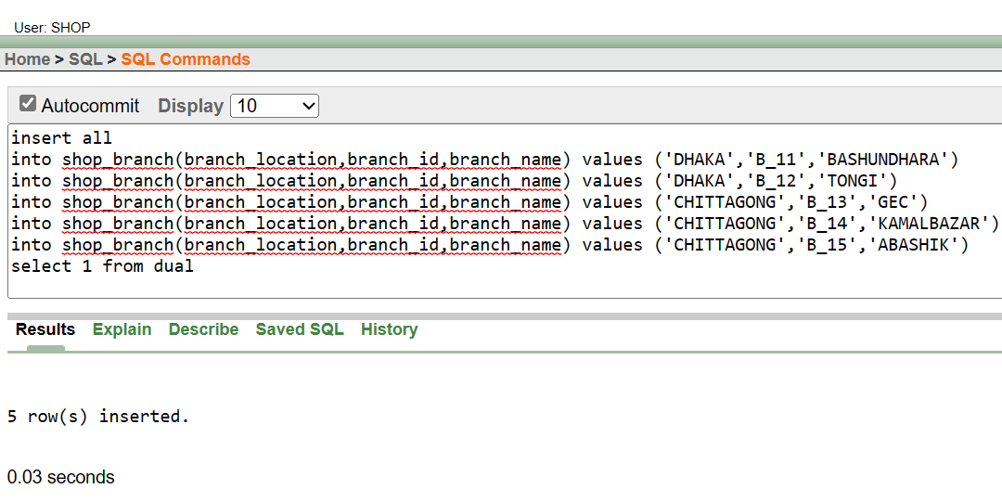

Figure:7.1

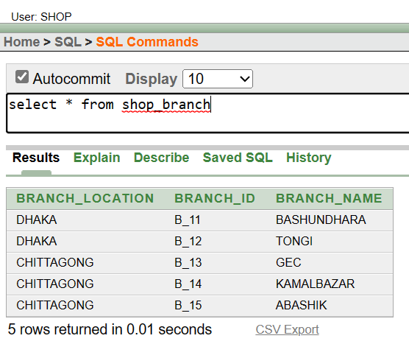

Figure:7.2

Supplier:

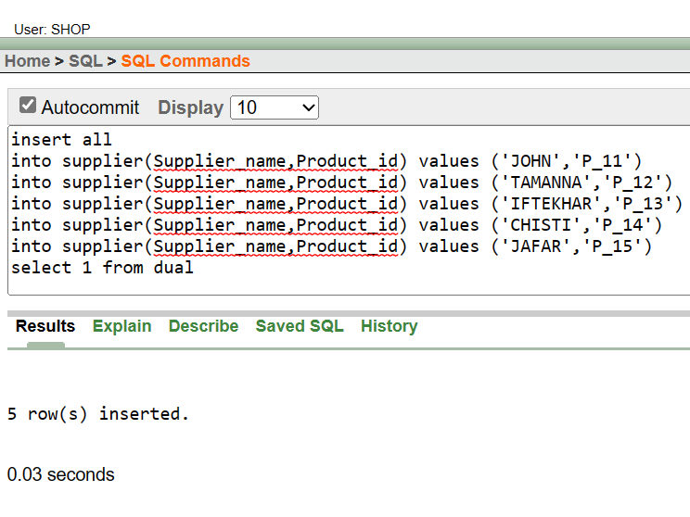

Figure:7.3

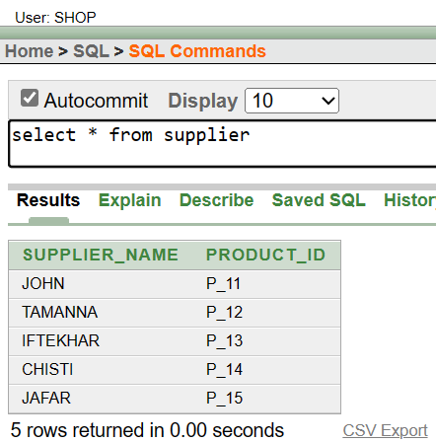

Figure:7.4

Supply:

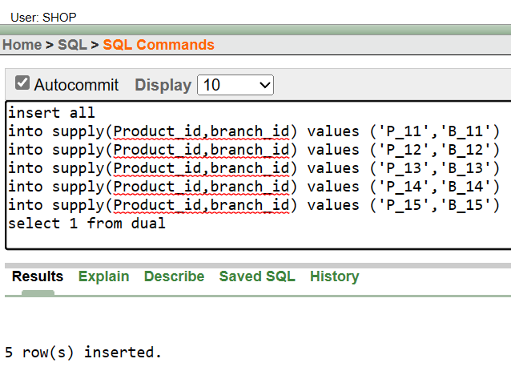

Figure:7.5

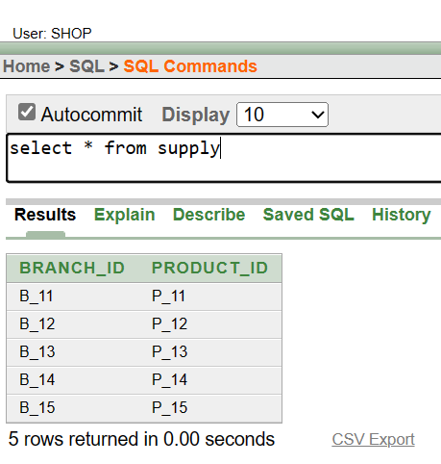

Figure: 7.6

Location:

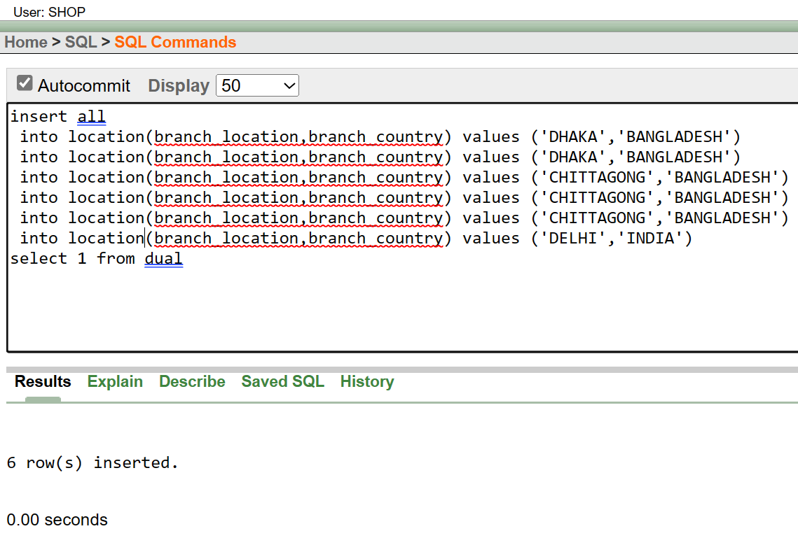

Figure:7.7

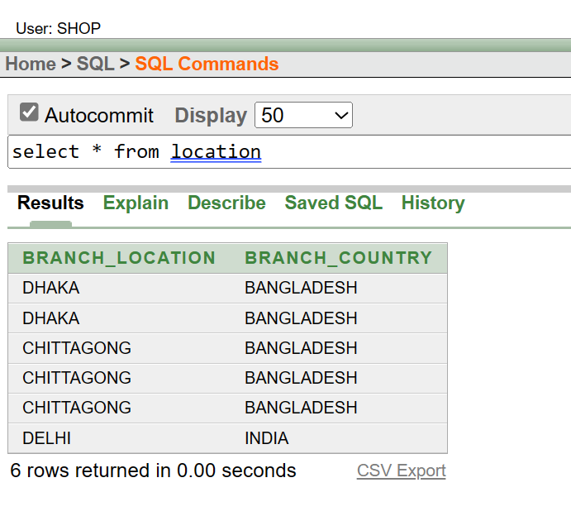

Figure:7.8

Manager:

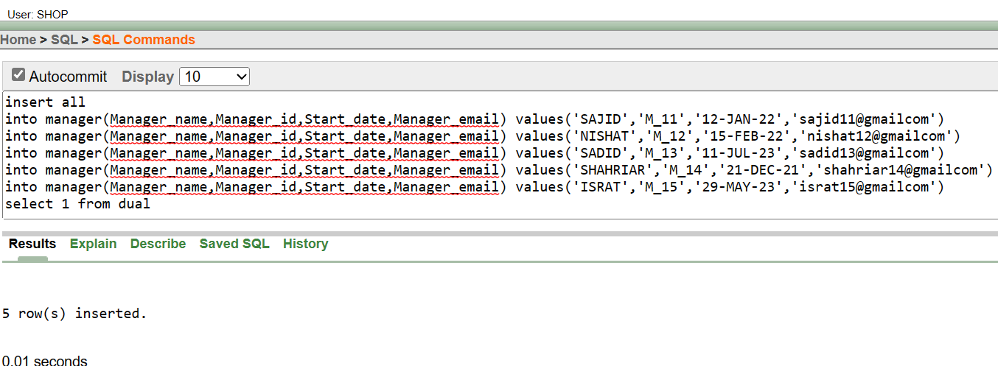

Figure:7.9

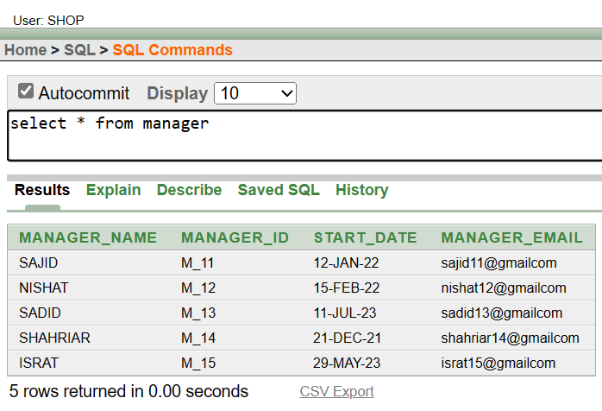

Figure:7.10

Manage:

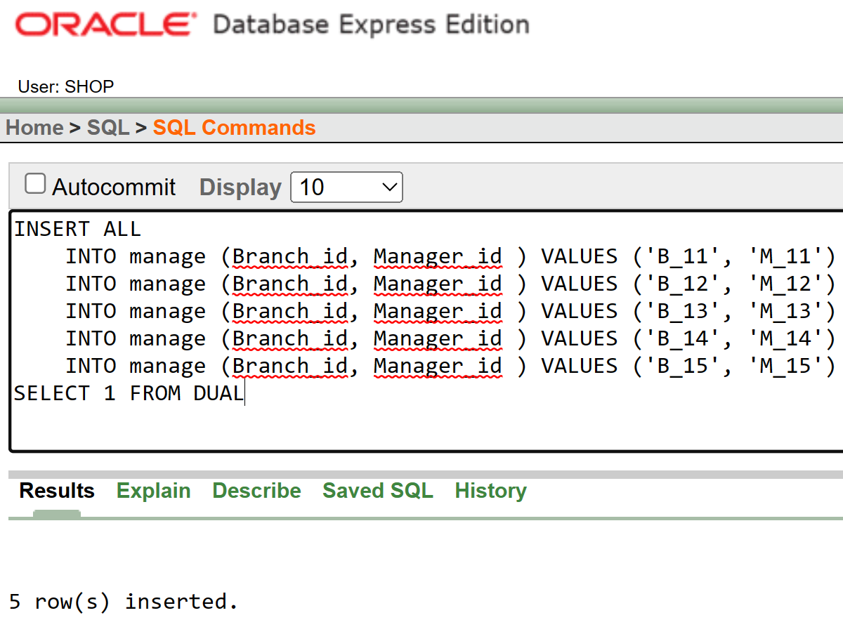

Figure:7.11

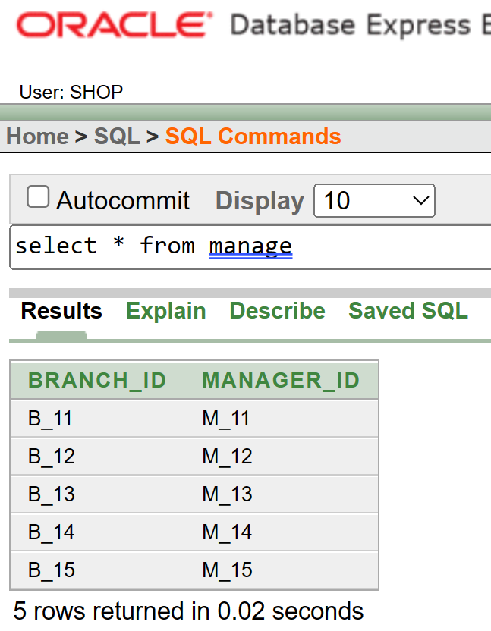

Figure:7.12

Work:

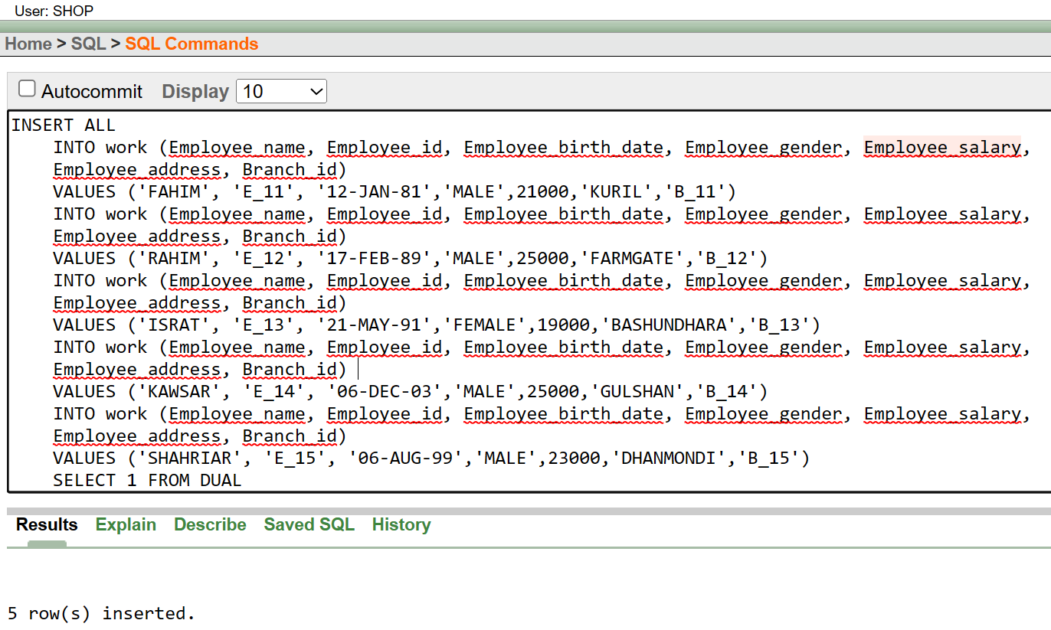

Figure:7.13

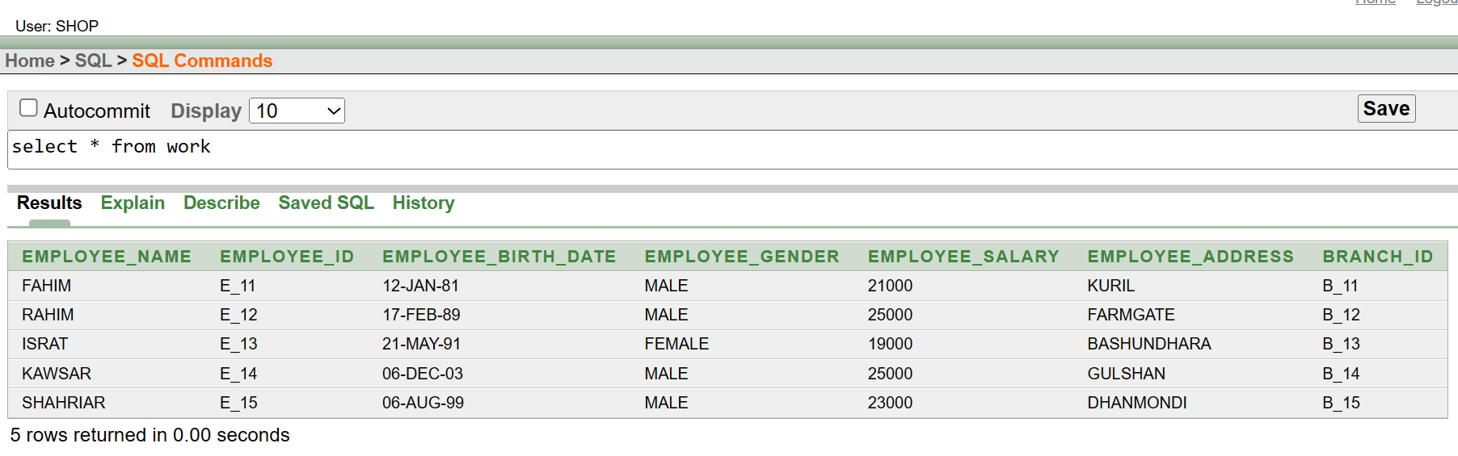

Figure:7.14

Employer:

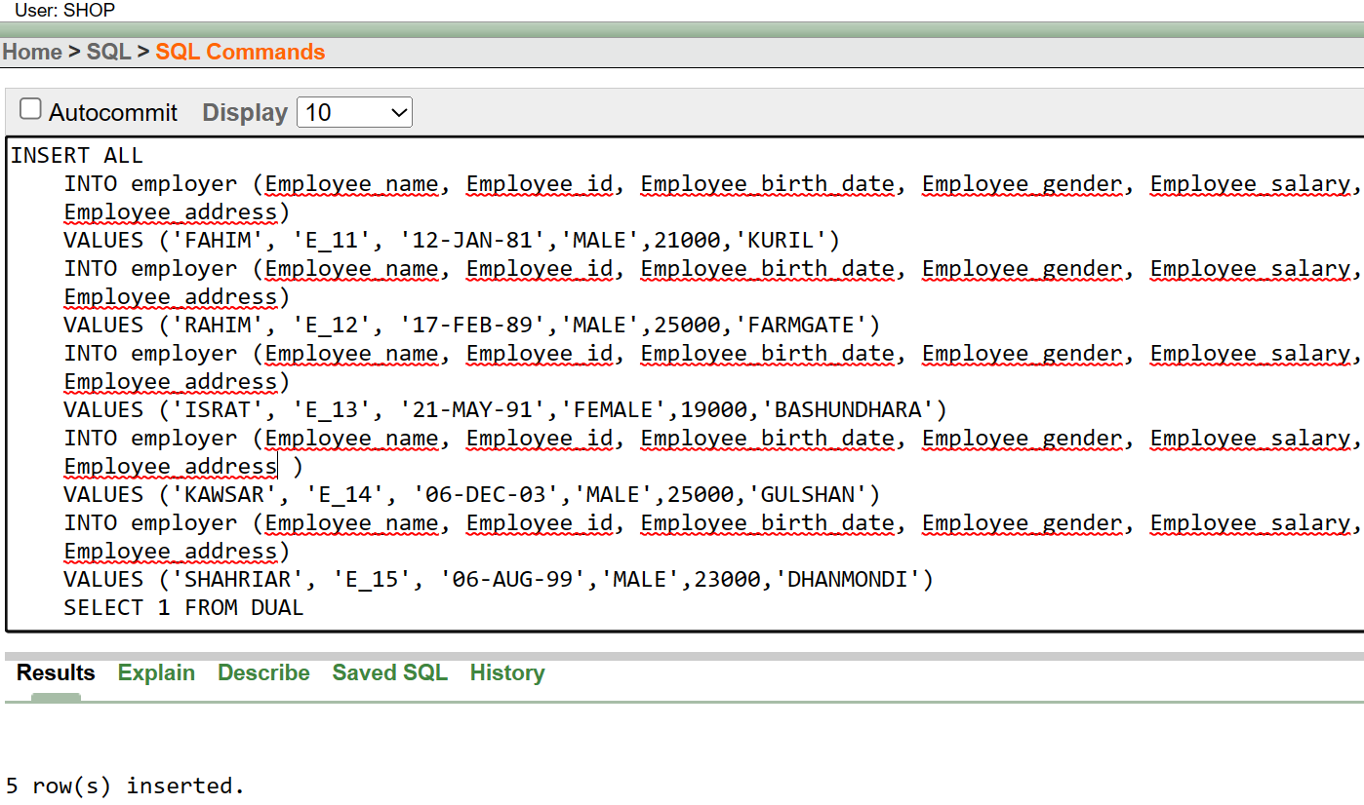

Figure:7.15

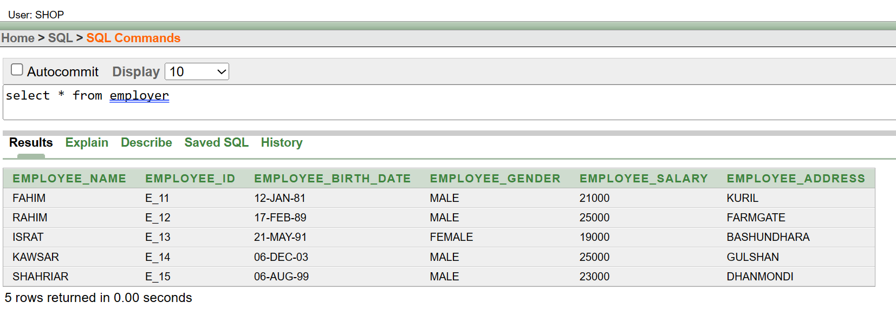

Figure:7.16

Client:

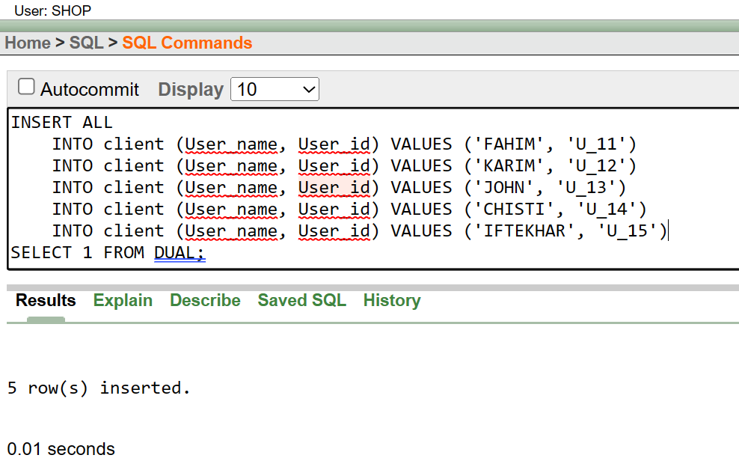

Figure:7.17

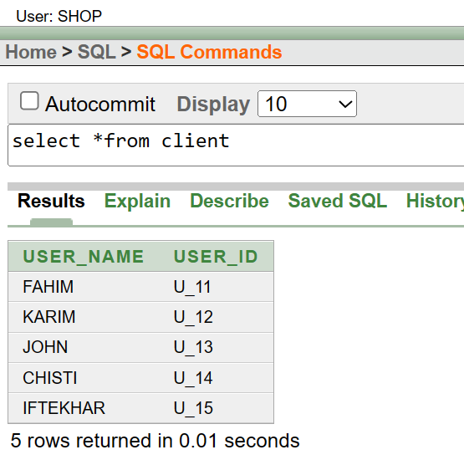

Figure:7.18

Collaborate:

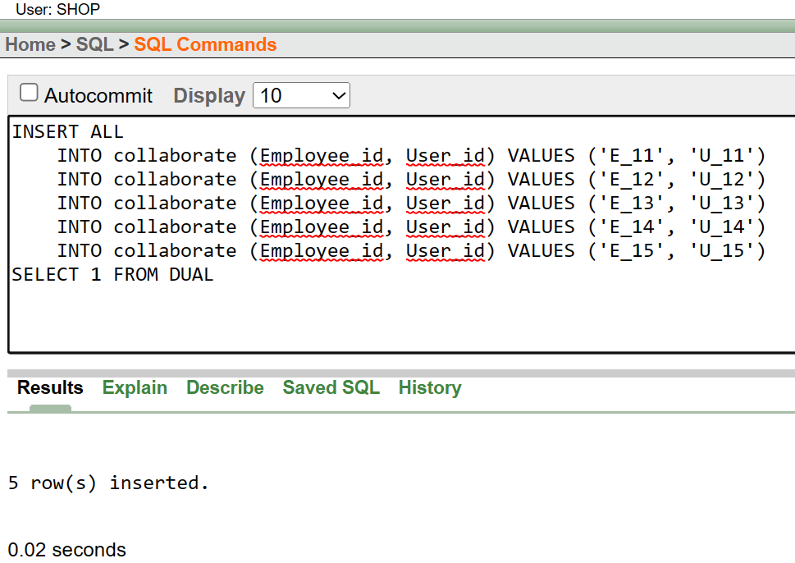

Figure:7.19

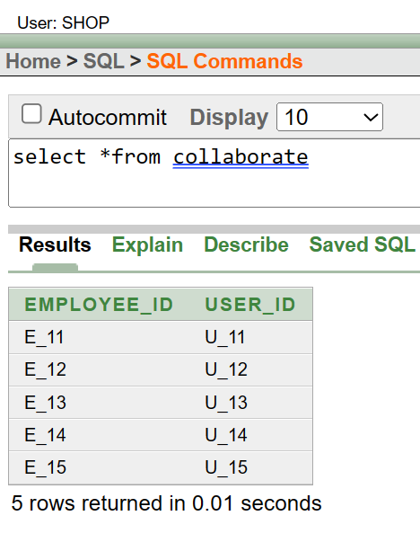

Figure:7.20

QUERY TEST:

1. Simple Query:

Show the employee name and employee gender from work table where employee id = 'E_13'.

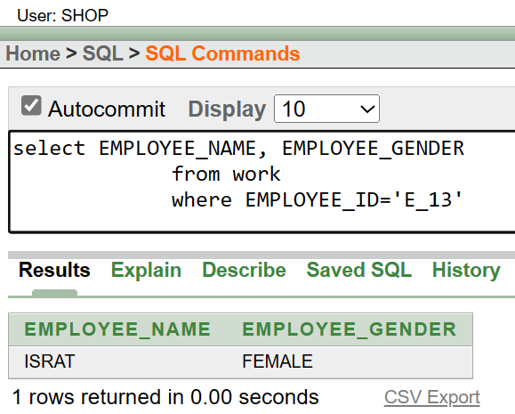

Figure: 8.1

2. Aggregate Function Query:

What are the average and total salaries of employees grouped by gender in the 'work' table

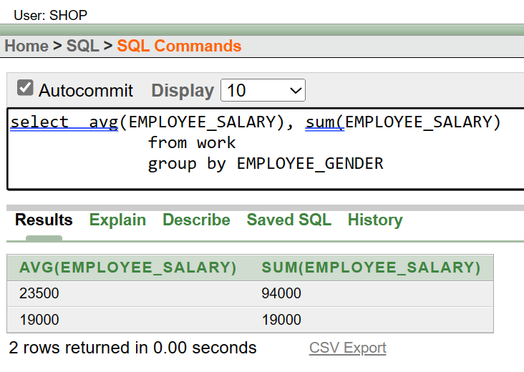

Figure: 8.2

3. Single Row Subquery:

Show the names and salaries of employees who earn more than the salary of the employee named 'ISRAT' in the 'work' table

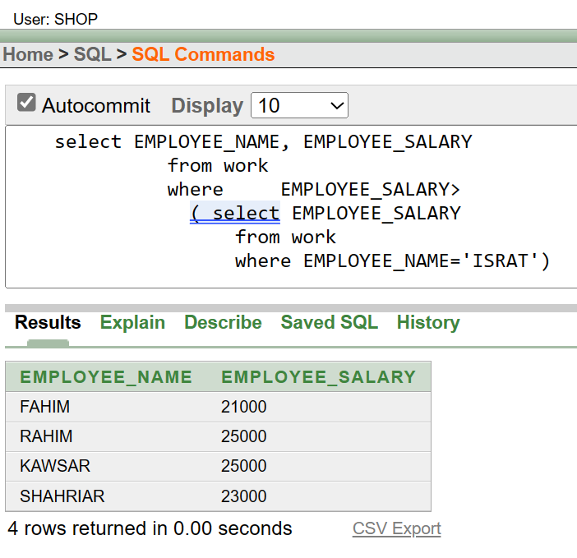

Figure: 8.3

4. Multiple Row Subquery:

Show the names, ID’s, and genders of employees whose salaries are lower than that of employees residing in the 'GULSHAN' area, excluding those who also live in the 'GULSHAN' area.

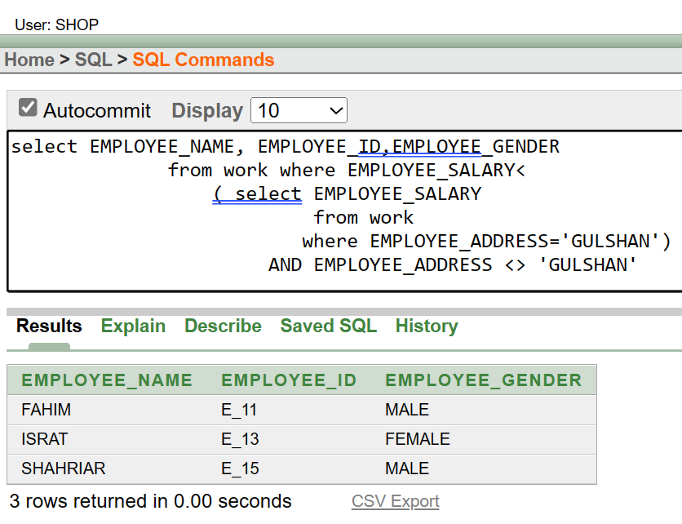

Figure: 8.4

5. Equijon:

Show the names and IDs of employees from the 'Work' table along with the corresponding employer's employee ID and branch ID from the 'Employer' table.

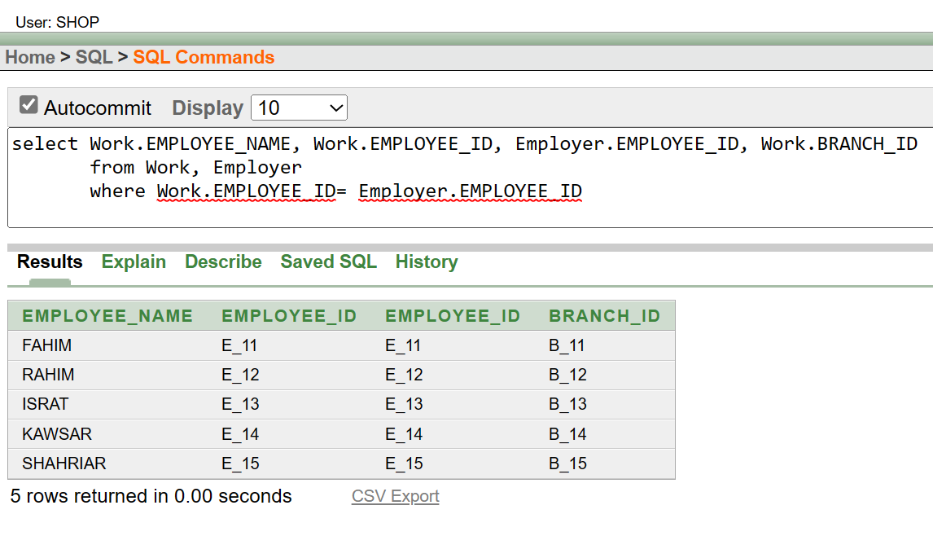

Figure: 8.5

Outerjoin:

Show the branch name, branch location, and branch country of shop branches, including those without a specific location, by joining the 'shop_branch' and 'location' tables using an outer join.

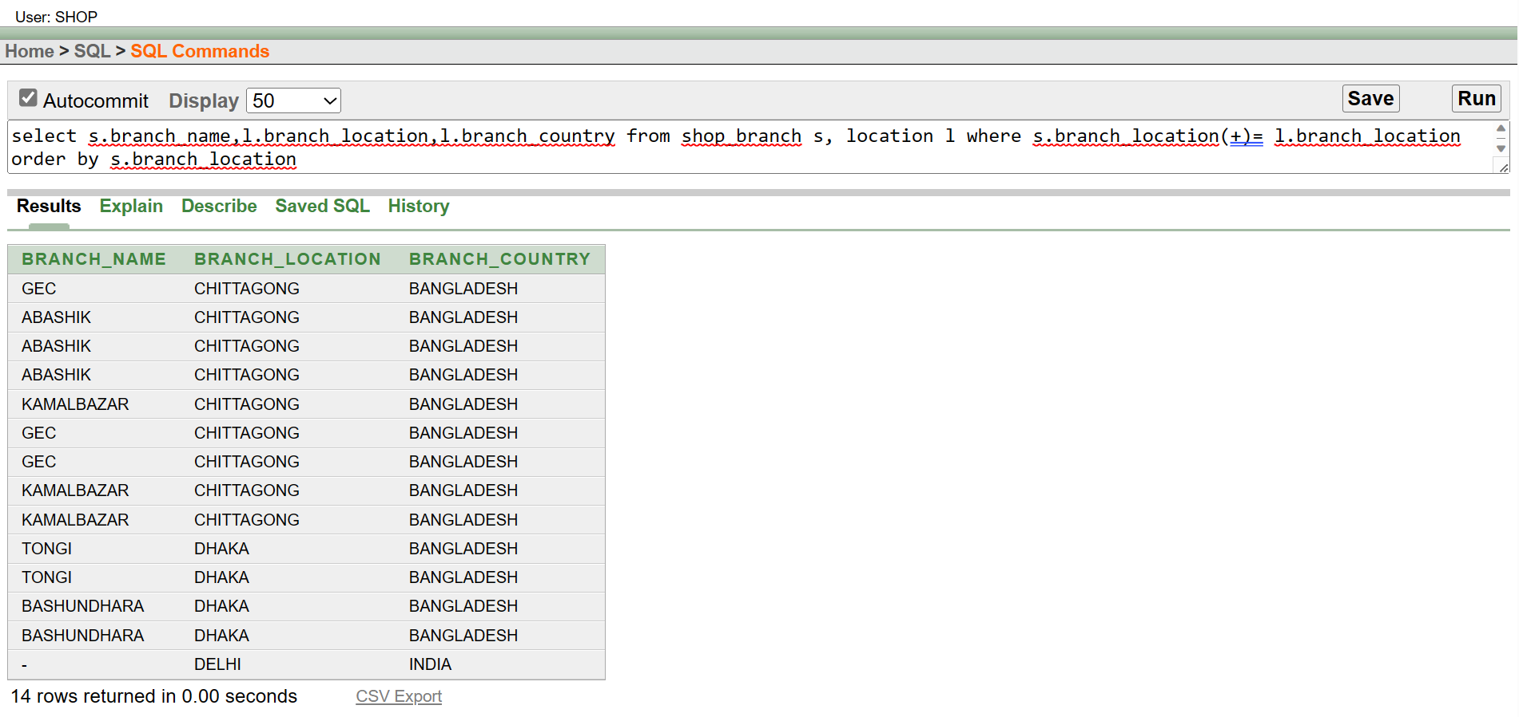

Figure: 8.6

6. Simple View:

Create a view that presents the employee's name and gender from the work table, filtering specifically for the employee with the ID= 'E_13'

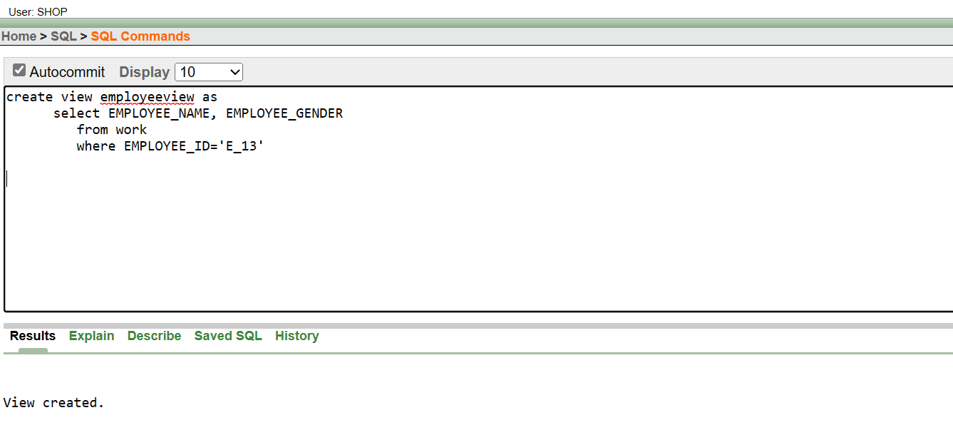

Figure: 8.7

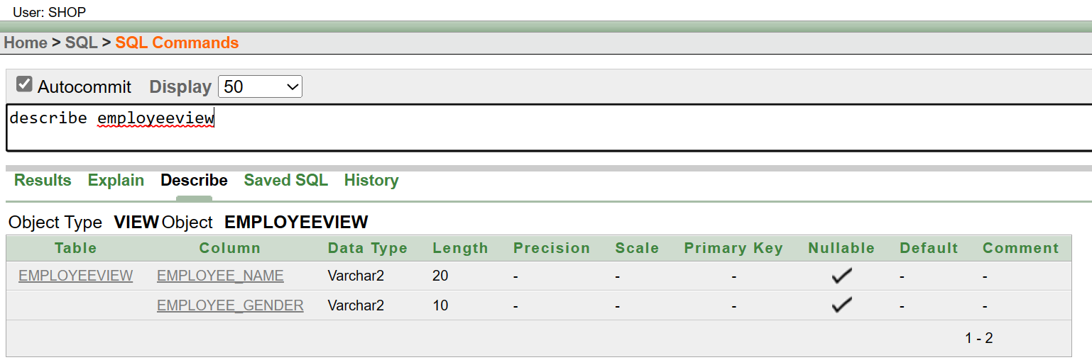

Figure: 8.8

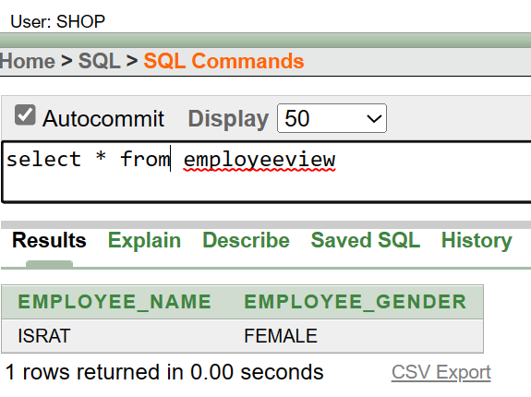

Figure: 8.9

Complex View:

Create a view that presents the names and IDs of employees from the 'Work' table along with the corresponding employer's employee ID and branch ID from the 'Employer' table.

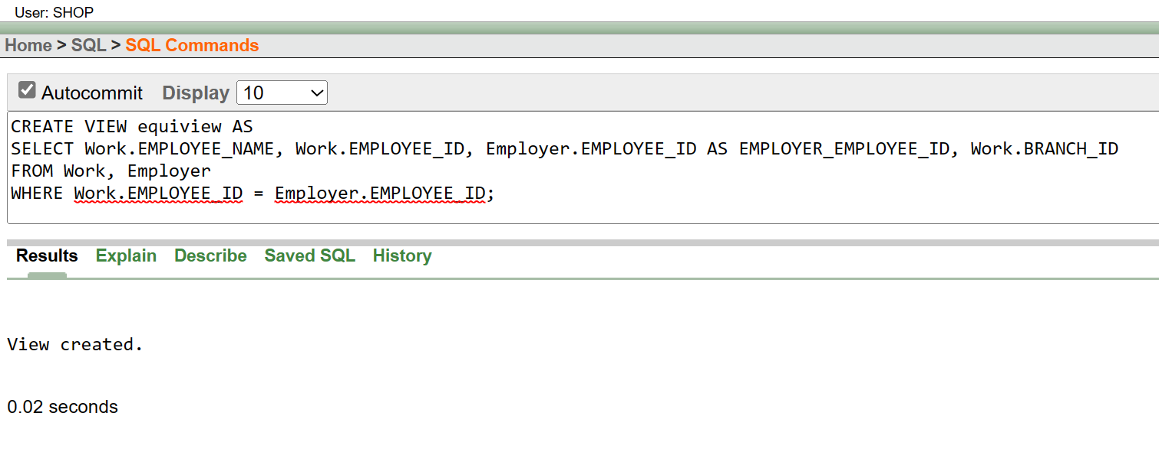

Figure: 8.10

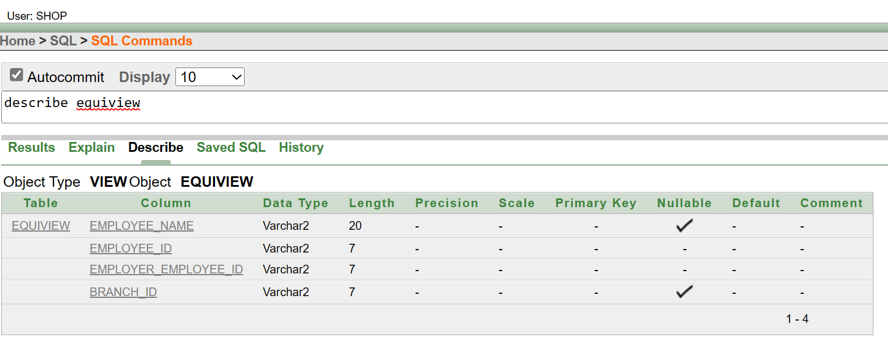

Figure: 8.11

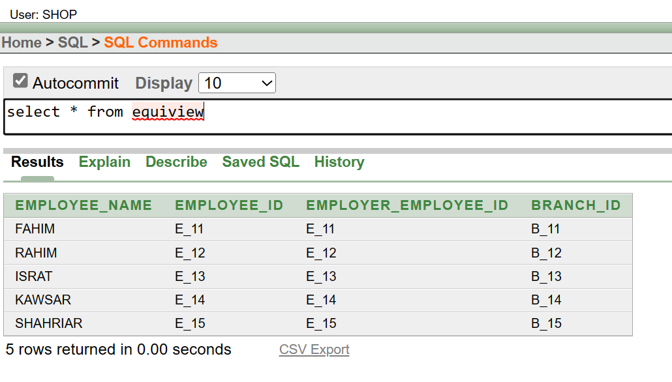

Figure: 8.12

Conclusion:

Bata Footwear's worldwide story involves capable managers running branches, employees engaging with customers, and suppliers ensuring smooth product distribution. This project highlights how these parts work together, showcasing Bata's important role in the industry.